- Milestone 1 -

1 Game Summary
In this game, players take control of a robotic suit. They travel around a tile-based map, picking up upgrades which they can load into their suit to increase their power and score. Players can also battle each other to gain score and defend their high score.

2 Players
2.1 Account Types
2.1.1 Overview
There are two account types:
- Administrator
- Player

2.1.2 Administrator
Administrator accounts have a more back-end view of the game.

2.1.3 Administrative Abilities
Administrator accounts have the following abilities:
- Lock/Unlock accounts
- Delete accounts
- Change inactive account types (Admin/Player)
- Kick active accounts from the game
- Create new accounts
- Change the information of an existing account

2.1.4 Player
Player accounts have a more front-end view of the game.

1.2.5 Player Abilities
Users with player accounts have the ability to delete their own account.

2.1.6 Login
Each player has a username and password.

When a player attempts to log in, if the username they have entered is not in the database, the user will be asked if they want to make a new account, if they say yes then a new account will be created with the entered username and password.

When a new account is created, the player will automatically be joined into the game.

If the username is in the database but the entered password does not match, the player will be told that the login failed and asked to try again.

If the player inputs a wrong password 5 times, the username they were attempting to log in to will be locked and they will be presented with an administrator email to contact. Locked accounts cannot be logged in to by anyone until an administrator unlocks the account.

If the username and password are correct, the player will be successfully logged in and able to play.

3 Stats
3.1 Overview
There are 4 player statistics:
- Strength
- Speed
- Health
- Energy

Each player also has a statistic total which is determined by the sum of the 4 statistics values. (E.g. 2 Strength + 2 Speed + 1 Health + 1 Energy = 6 Stat Total)

3.2 Strength
Strength is the statistic used to determine damage output. Ability base damage is multiplied based on it.

3.3 Speed
Speed is the stat used to determine the frequency / movement time for a player to go to different tiles.

3.4 Health
Health is the player stat that affects the maximum health value a player can have.

3.5 Energy
Energy is the player stat that affects the speed which players regenerate energy at.

4 Classes
4.1 Overview
There are 4 classes:
- Gorilla
- Cheetah
- Eagle
- Tiger

Each class has an increase (+1) to 2 statistics and a decrease (-1) to 2 statistics.

Each class also has a unique starting ability.

4.2 Gorilla
The gorilla class begins with increased strength and health but decreased speed and energy.

The gorilla class starts with the piston wreck ability.

4.3 Cheetah
The cheetah class begins with increased speed and energy but decreased strength and health.

The cheetah class starts with the hyper-speed kick ability.

4.4 Eagle
The eagle class begins with increased speed and health but decreased strength and energy.

The eagle class starts with the wing swipe ability.

4.5 Tiger
The tiger class begins with increased strength and energy but decreased speed and health.

The tiger class starts with the claw strike ability.

5 Abilities
5.1 Overview
Abilities are actions which energy can be expended to use.

Any class can use any ability.

Each ability has the following details:
- Name
- Description
- Value
- Energy cost
- Use time

Abilities which can be used in combat also have a damage output.

The value of each ability changes the player's score. When an item is removed from the player's inventory, their score will decrease. When an item is added, it will increase.

6.1 Energy
Every ability uses some amount of energy. Energy regenerates at a speed based on the player's energy stat.

6.2 Using Abilities
Players can use abilities by clicking on an available ability icon.

6.3 Ability Availability
Ability availability is based on the following criteria:
- Ability use case
- Energy cost vs energy amount
- Recently used abilities

6.4 Ability Use Case
If an ability can only be used in combat, but the player is not engaged in combat, then the ability will not be available.

6.5 Energy Cost VS Energy Amount
If the amount of energy which an ability needs is greater than the player's current energy amount, the ability won't be available.

6.6 Recently Used Abilities
For a short period (~0.5 Seconds) after an ability is used, it will be unavailable. This is more to avoid ability spam.

7 Score
7.1 Overview
Each player has a score which increases as they play.

When a player is defeated, their score resets to 0.

Each player also has a high score which is displayed in the leaderboard.

8 Combat
8.1 Overview
When one player is adjacent to another player, they can click on the other player to engage in combat.

Combat can be exited by clicking on another tile to move away.

When in combat, players use their combat abilities to damage each other and reduce their opponent’s health.

Winning in combat increases the winning player's score based on the score of the losing player and their statistic point total.

When a player is defeated, they lose all of their upgrades and are sent back to the home tile with their starting loadout.

9 Map
9.1 Tiles
9.1.1 Overview
The map is made up of tiles. Each tile can contain 4 items and (with one exception) 1 player.

9.1.2 Home Tile
All players initially start on the home tile; this is the only tile which is able to hold multiple players.

9.1.3 Rejoining
When a player leaves and rejoins the game, they will be placed back on the tile which they were on when they left the game. If this is not possible, then they will be asked to select a new valid tile to spawn on.

9.2 Movement
9.2.1 Overview
Players move around the map by clicking on adjacent tiles. If a tile is empty (no other player on it) then the player is able to move to it, otherwise they will engage in combat with the other player.

The amount of time which a player must wait to move is determined by their speed stat, with 0 wait time being the absolute minimum.

Players can still enter combat and access the tiles items while they are waiting to be able to move again.

If two players click on the same empty tile, the first player to click the tile will be the one who moves, the other player will not move.

10 Pickups
10.1 Overview
Players pick up items from tiles. Every item grants the user either an ability or statistic change.

Players can hold up to 4 ability items and 4 stat items.

To pick up or drop an item, the player clicks on the item and then where what valid inventory slot they want to move it to (this can either be on the player or the tile).

10.2 Glitch Abilities
10.2.1 Overview
Glitch abilities are pickups which randomly move around the map to empty tiles every second. If a player moves to a tile with a glitch ability, it will temporarily stop moving.

As soon as the player leaves the tile, the glitch ability will move.

11 Chat
11.1 Overview
Players are able to send messages through the in-game chat.

Each message has a username, send datetime, and the message text itself.

12 Ability Library
The following is a list of each ability and its details:

Iron Core
Type: Upgrade
Description:
+1 Health | -1 Speed

A forged iron core to increase the durability of a suit.

Value: 5

Steel Core
Type: Upgrade
Description:
+3 Health | -2 Speed

A forged steel core to better increase the durability of a suit.

Value: 10

Platinum Core
Type: Upgrade
Description:
+5 Health | -3 Speed

A forged platinum core to greatly increase the durability of a suit.

Value: 15

Loose Spring
Type: Upgrade
Description:
+1 Health | -1 Strength

A stretched spring, not very springy but bends easily.

Value: 5

Tight Spring
Type: Upgrade
Description:
+1 Strength | +1 Energy | -2 Health

A firm spring, plenty of potential energy but not very flexible.

Value: 10

Overtightened Spring
Type: Upgrade
Description:
+3 Energy | +2 Strength | -4 Health

A spring that seems to have somehow been twisted past its usual breaking point. Extremely high potential energy but will not hold up well to stress.

Value: 15

Ping
Type: Ability (Utility)
Description:
Scan the surrounding area for signals. (Tile inventory will include surrounding tiles as well until player moves)

Value: 12
Energy Cost: 5

Piston Wreck
Type: Ability (Combat) - Gorilla Starting Ability
Description:
Utilise the added force of the pistons in a suit to increase the power of a punch.

Value: 6
Energy Cost: 1
Base Damage: 2

Wing Swipe
Type: Ability (Combat) - Eagle Starting Ability
Description:
Swipe a suit's wing (or arm) with the added assistance of its propulsion jet.

Value: 6
Energy Cost: 1
Base Damage: 2

Claw Strike
Type: Ability (Combat) - Tiger Starting Ability
Description:
Use a suit’s claws (or fist) to damage a target.

Value: 6
Energy Cost: 1
Base Damage: 2

Hyper-Speed Kick
Type: Ability (Combat) - Cheetah Starting Ability
Description:
Utilise the fast bearings in a suit’s legs to kick a target at increased speed.

Value: 6
Energy Cost: 1
Base Damage: 2

Jump-Kick
Type: Ability (Combat)
Description:
Jump into the air and kick a target.

Value: 10
Energy Cost: 4
Base Damage: 5

Laser
Type: Ability (Combat)
Description:
Fire a high-powered laser at a target.

Value: 16
Energy Cost: 6
Base Damage: 10

Teleport
Type: Glitch Ability (Utility)
Description:
Phase-shift a suit and its occupant to a different place. (Move to any empty tile on the map)

Value: 30
Energy Cost: 10

Speed Shift
Type: Glitch Upgrade
Description:
+5 Speed

A mechanical switch which makes it substantially faster to shift up (and down) speed levels of a suit.

Value: 25

Iron Plating
Type: Upgrade
Description:
+1 Health | -1 Energy

Forged iron plating for the exterior of a suit. Seems to interfere with energy conduction.

Value: 5

Steel Plating
Type: Upgrade
Description:
+3 Health | -2 Energy

Forged steel plating for the exterior of a suit. Seems to interfere with energy conduction.

Value: 10

Platinum Plating
Type: Upgrade
Description:
+5 Health | -3 Energy

Forged platinum plating for the exterior of a suit. Seems to interfere with energy conduction.

Value: 20

Overcharge
Type: Glitch Upgrade
Description:
+5 Energy

Send an excess amount of energy around the suit, disregarding component damage.

Value: 28

Cell
Type: Upgrade
Description:
+1 Energy | -1 Strength

An energy cell to store energy for later use. Seems to bounce off of surfaces easily.

Value: 3

Double-Cell
Type: Upgrade
Description:
+4 Energy | -2 Strength

Two energy cells to store more energy for later use. Seem to bounce off of surfaces easily.

Value: 6

Triple-Cell
Type: Upgrade
Description:
+6 Energy | -3 Strength

Three energy cells to store a lot more energy for later use. Seem to bounce off of surfaces easily.

Value: 12

Quad-Cell
Type: Upgrade
Description:
+8 Energy | -5 Strength

Four energy cells to store an overwhelming amount of energy for later use. Seem to bounce off of surfaces easily. One might question the diminishing returns of so many cells.

Value: 24

11 Storyboards
- Login Screen
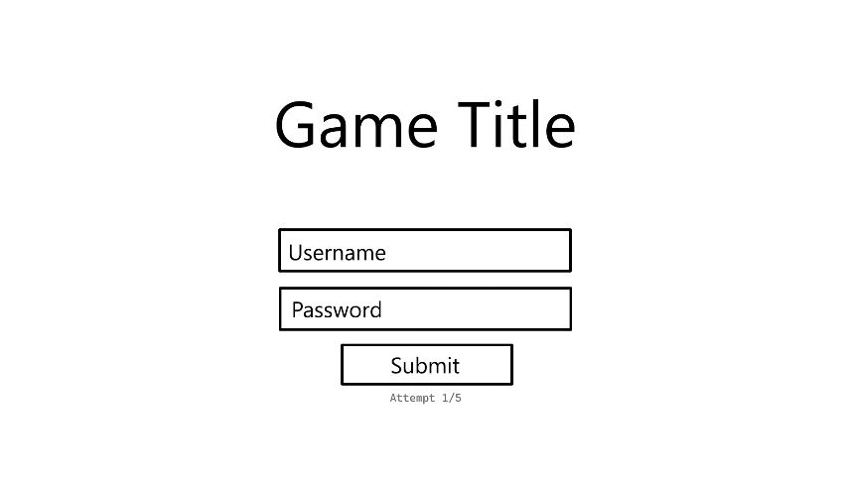  4  3  2  1 | - Text Input – A text box for the player to write their username. This input is compared to the usernames in the database when the user tries to log in.  - Text Input – A text box for the player to write their password. This input is compared to the password in the database when the user tries to log in.  - Button – Attempts to log in with the given information. If the username and password are correct sends the player to the room select menu (Storyboard 4) and sets the accounts attempts value to 0 in the database, if the username is not in the database (Storyboard 2), or if the password is not associated with the given username in the database, the player will be told that the username or password was wrong and given another attempt up to 5 times. After the fifth failure, the account with the given username will have its locked value set to true in the database and the player will be shown the account lockout message. (Storyboard 3)  - Text – Displays the players sign in attempt count. Gets this information from the account login attempts value in the database. Gets the value associated with the given username so will change when the username is changed.
| |  | |
- Account Registration Popup
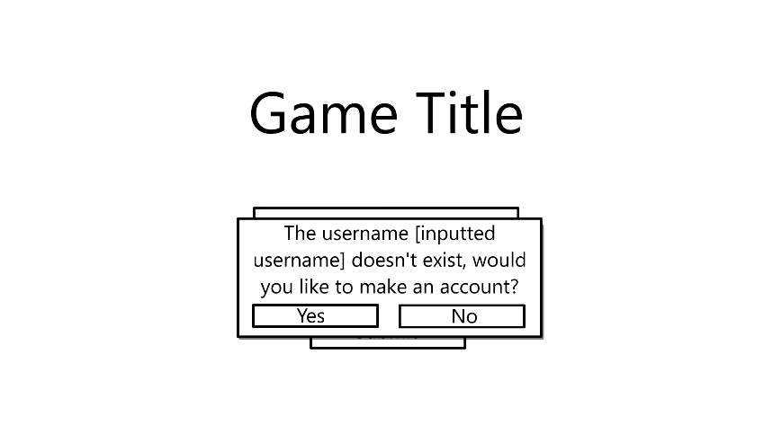  2  1 | - Button – Creates a new account with the given username and email in the database. Automatically logs the player in and sends them to the room select menu. (Storyboard 4)  - Button – Takes the player back to the login screen. (Storyboard 1)
| |  | |
- Locked Account Message
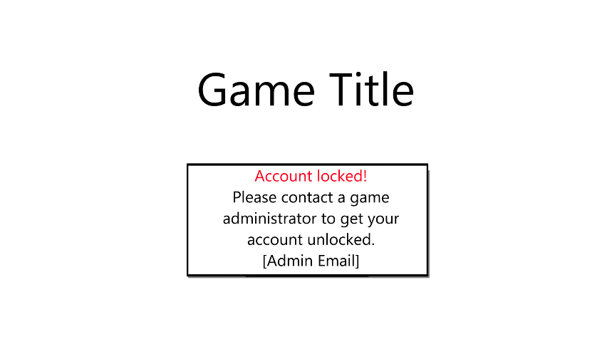 | This menu will completely lock the player out of logging in until they restart the game.
| | |
- Room Selection Screen
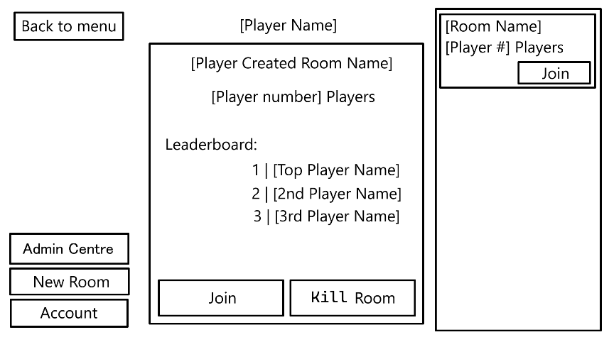  7e  7d  7c  7b  7a  7  6  5c  5b  5a  5  4  3  2  1 | - Button – Returns the player to the login screen. (Storyboard 1)  - Button – Only visible to accounts in the database with the administrator value set to true. Takes the player to the administrator menu. (Storyboard 6)  - Button - Tries to initiate the room creation process. If the player doesn’t already have a room with their username attached in the database(Storyboard 8), if the player has already created a room. (Storyboard 9)  - Button – Opens the account options menu. (Storyboard 5)  - List – A scrollable menu of all available rooms pulled from the database.  5a. Text – The name of the room.  5b. Text – How many players are currently in the room.  5c. Button – Joins the player to the room. (Storyboard 18)  - Text – The player’s username.  - Menu – Details of the player’s currently created room. Blank if there is no room.  7a. Text – The name of the current room.  7b. Text – The current number of players in the room.  7c. Button – Joins the player to the room. (Storyboard 18)  7d. Button – Opens the room deletion menu. (Storyboard 10)  7e. List – Displays the current players in first, second and third place, if applicable.
| |  | |
- Player Account Options
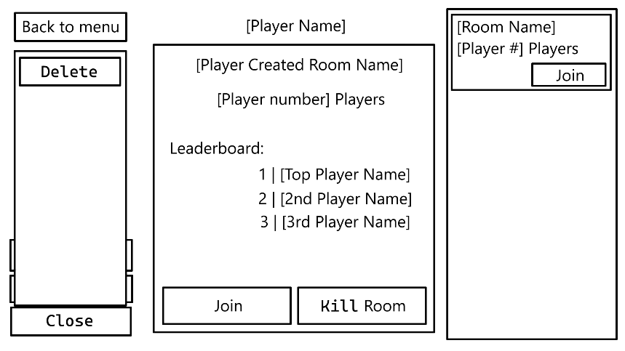  1 | - Button – Asks if user is sure. (Storyboard 14)
| | |
- Administrator Screen (Rooms)
3
2a
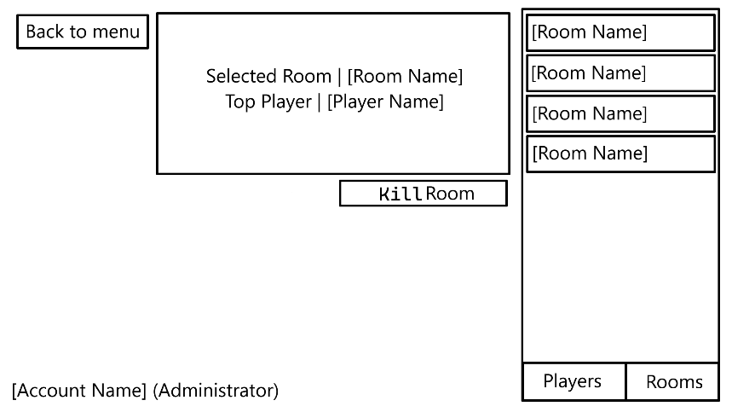  5  4  3b  3a  2c  2b  2  1 | - Button - Takes the player back to the room selection menu. (Storyboard 4)  - List – A list of all available rooms pulled from the database.  2a. Button – Selects the corresponding room.  2b. Button – Takes the player to the player menu. (Storyboard 7)  2c. Button – Greyed out because selected.  - Menu – Displays information about the currently selected room.  3a. Text – The name of the room.  3b. Text – The username of the player with the highest score in the currently selected room.  - Text – The player’s username.  - Button - Opens the room closure confirmation popup. (Storyboard 15)
| | |
- Administrator Screen (Players)
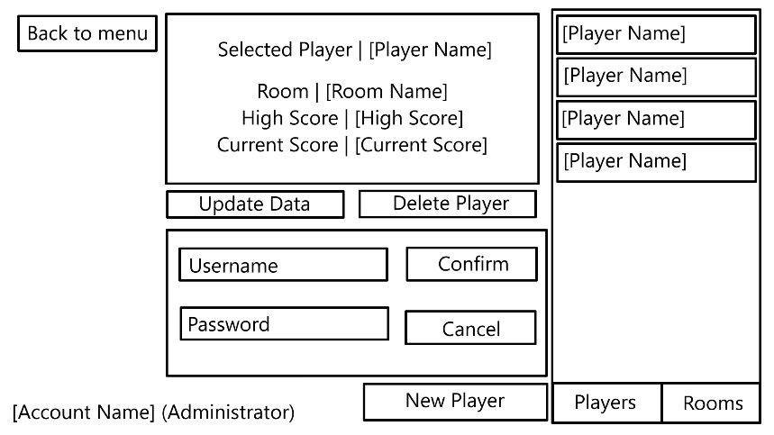  7e  7d  7c  7b  7a  7  6  4  3d  3c  3b  3a  3  2c  2b  2a  2  1 | - Button - Takes the player back to the room selection menu. (Storyboard 4)  - List – A list of all available players from the database.  2a. Button – Selects the corresponding player.  2b. Button – Greyed out because selected.  2c. Button – Takes the player to the room menu. (Storyboard 6)  - Menu – Displays information about the currently selected player.  3a. Text – The player’s username.  3b. Text – The player’s current room, if applicable.  3c. Text – The player’s current high score, if applicable.  3d. Text – The player’s current score, if applicable.  - Text – The player’s username.  - Button - Shows the player deletion confirmation popup. (Storyboard 17)  - Button - Takes the player to the player info edit menu. (Storyboard 16)  - Menu – Input methods to create a new player. Only visible when creating a new player.  7a. Text Input – A text input for the player to input a username.  7b. Button – Attempts to create a new player with the given information.  7c. Text Input – A text input for the player to input a password.  7d. Button – Cancels the player creation and closes the popup.  7e. Button – Opens the popup.
| | |
- Room Creation
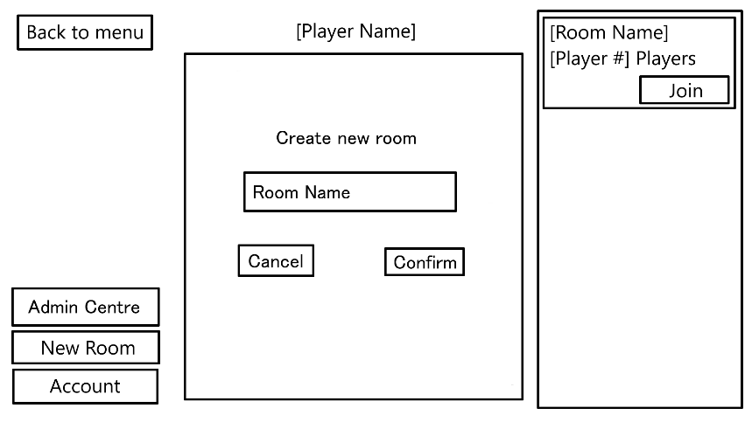  3  2  1 | - Button – Closes the menu. (Storyboard 4)  - Button –Tries to create the room and automatically connect the player.  - Text Input – A text box for the player to write a room name.
| | |
- Room Creation Existing Room Message
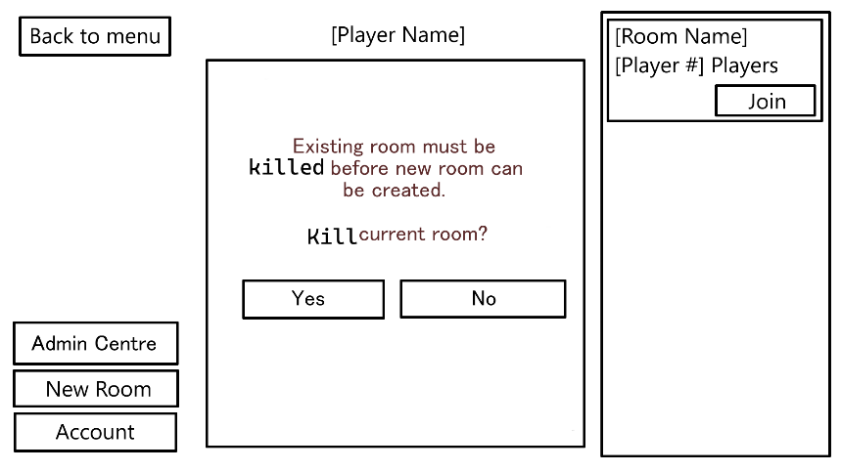  2  1 | - Button – Kills the room and goes to the room creation menu. (Storyboard 8)  - Button – Closes the menu. (Storyboard 4)
| | |
- Room Closing Message
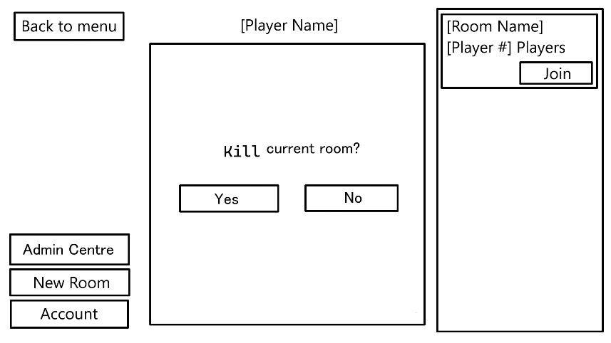  2  1 | - Button – Kills the room and goes back to the room select menu. (Storyboard 4)  - Button – Closes the menu. (Storyboard 4)
| | |
- Gameplay Screen
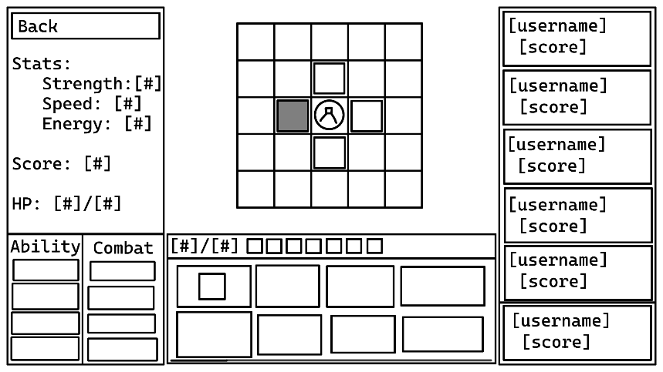  10  11  9  8  6  7  5a  5  4  3  1  2 | - Clickable Sprite – Displays a position which the player can move to, determined by the player’s latest position and the tiles around them. Creates a new entry in the player_tile table when clicked.  - Sprite – Displays a position which the player cannot move to.  - Sprite – Displays the player’s current position pulled from the player_tile table entry with the most recent timestamp.  - Button – Takes the player back to the room selection menu.  - List – Lists the current leaderboard from the players read from the player table where the room matches.  5a. Box – Shows the player’s current leaderboard position.  - Clickable Sprite – Tries to use the corresponding ability. Determined by the abilities in the player_ability table where the dropped value is NULL.  - Text – Displays the player’s current and maximum energy read from the database.  - Sprite – Displays an empty inventory slot.  - Clickable Sprite – Displays an occupied inventory slot. Clicking begins item movement process. (Storyboard 13)  - Text – Displays the player’s current statistics pulled from the player_statistic table.  - Scroll Bar – Scrolls the tile inventory if it exceeds the screen size.  The chat window will also open to the side with a multiline containing the message history and a text input for message input.
| | |
12. Glitch Item
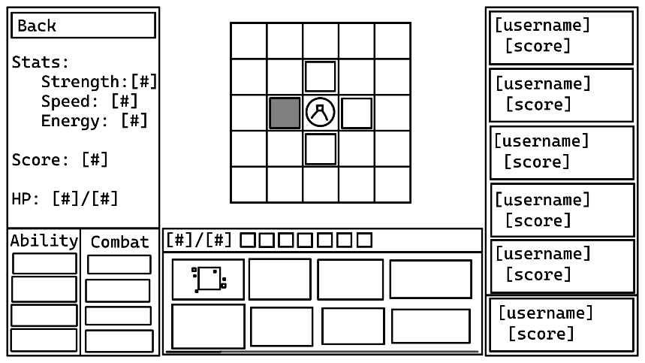  1 | - Clickable Sprite – Displays a glitch item. Glitch state is determined by the glitched value in the ability table. Relocates to a new random position on player movement.
| | |
- Item Movement
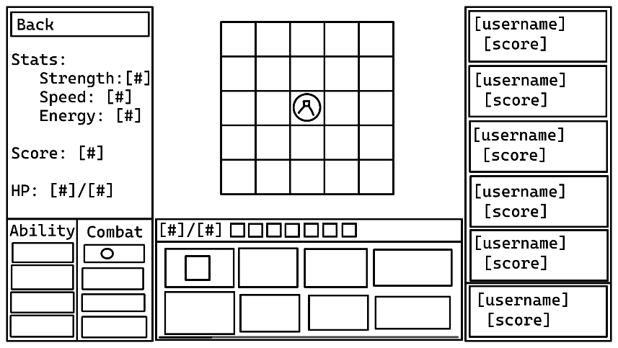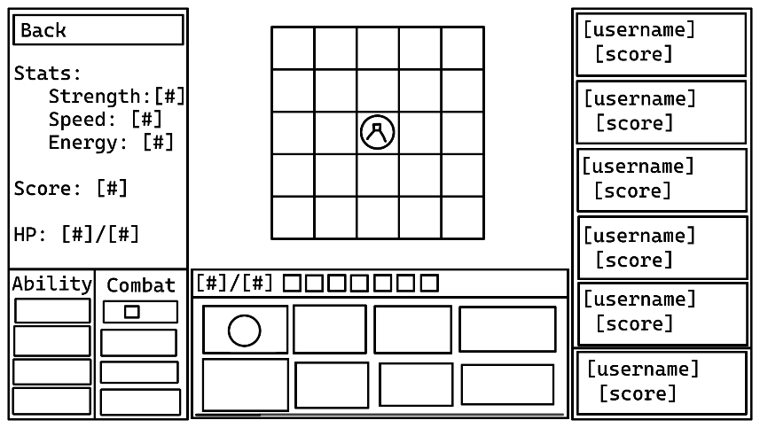  2  1 | - Clickable Sprite – Player selects the item to move.  - Clickable Sprite – Player selects item to swap with.  The items are the exchanged. If one of the slots is empty, then the empty slot will be filled and the filled slot will become empty.  The player’s score will update according to the items in their inventory at any given time.  When the items “swap”, the item in the player’s inventory will have its dropped value set to the current time and a new tile_ability entry will be created with the current time.
| | |
- Account Deletion Confirmation
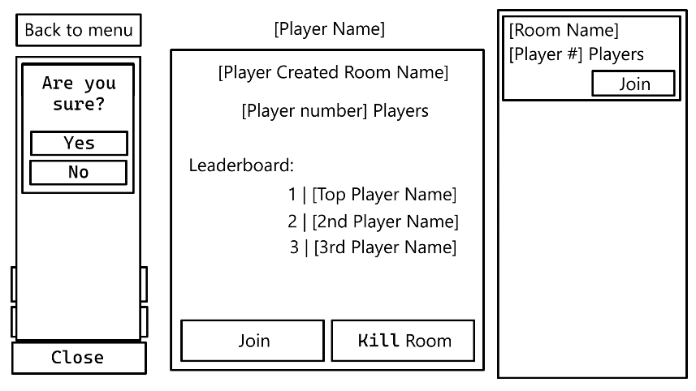  2  1 | - Button – Deletes the player’s account from the database and takes them back to the login screen. (Storyboard 1)  - Button – Closes the menu. (Storyboard 5)
| | |
- Room Closure Popup
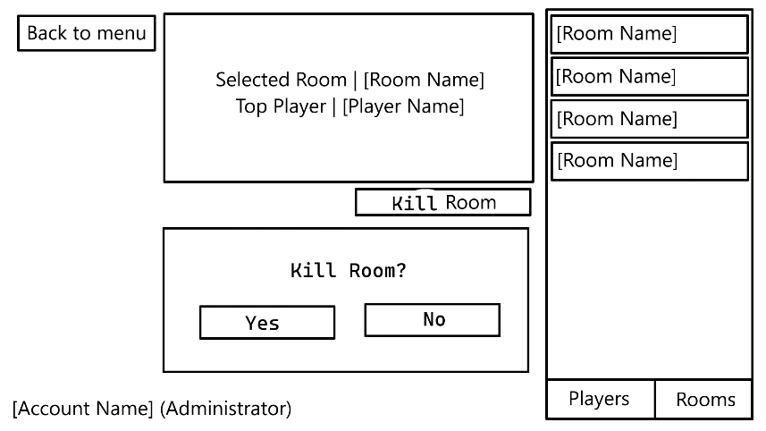  2  1 | - Button – Deletes the room and closes the menu. (Storyboard 6) Any players in the room will be sent to the room select screen. (Storyboard 4)  - Button – Closes the menu. (Storyboard 6)
| | |
- Player Info Edit Menu
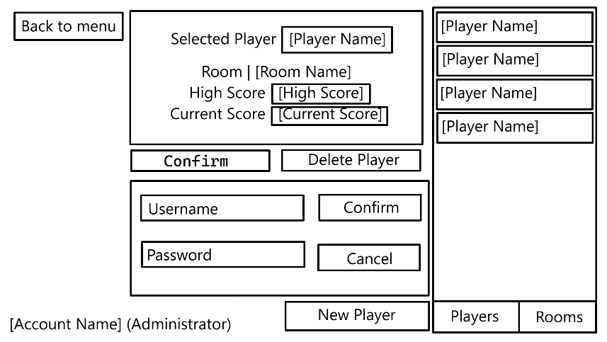  1  2  3  4 | - Textbox – A textbox to change the player’s username.  - Textbox – A textbox to change the player’s high score.  - Textbox – A textbox to change the player’s current score.  - Button – Changes the player’s details and moves back to non edit mode. (Storyboard 7)
| | |
- Player Deletion Confirmation Popup
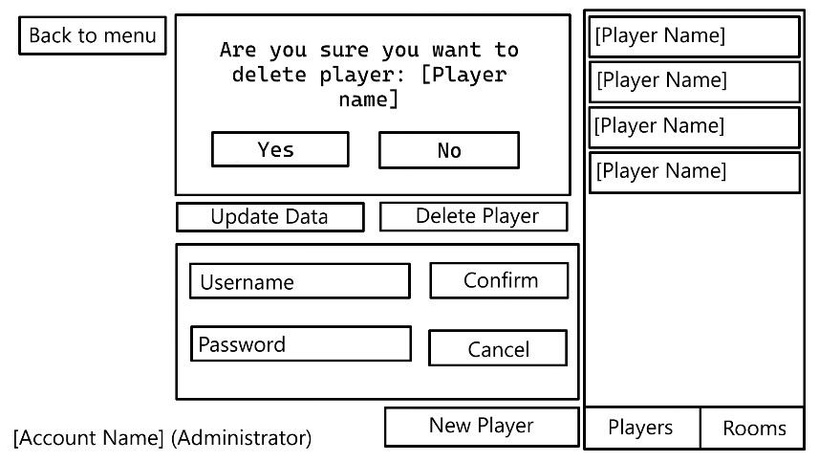  2  1 | - Button – Deletes the player and closes the popup. (Storyboard 7) Active players will be returned to the login screen. (Storyboard 1)  - Button – Closes the popup. (Storyboard 7)
| | |
- Room Join Menu
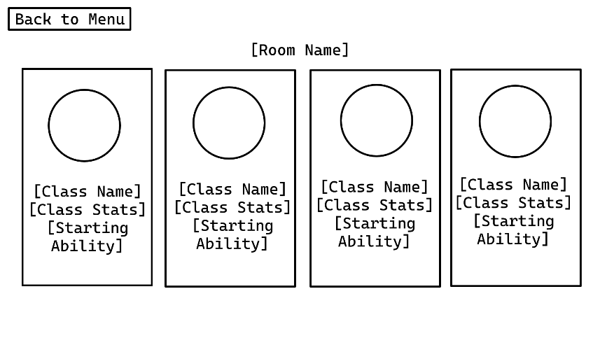  2d  2c  2b  2a  1  3  2 | - Button – Takes the player back to the room select menu. (Storyboard 4)  - Button – Selects the players class and sends them to the game board. (Storyboard 11)  2a. Sprite – The sprite for the player with this class.  2b. Text – The name of the class.  2c. Text – The stat changes from this class.  2d. Text – The starting ability of this class.  - Text – The name of the room.

12 ERD
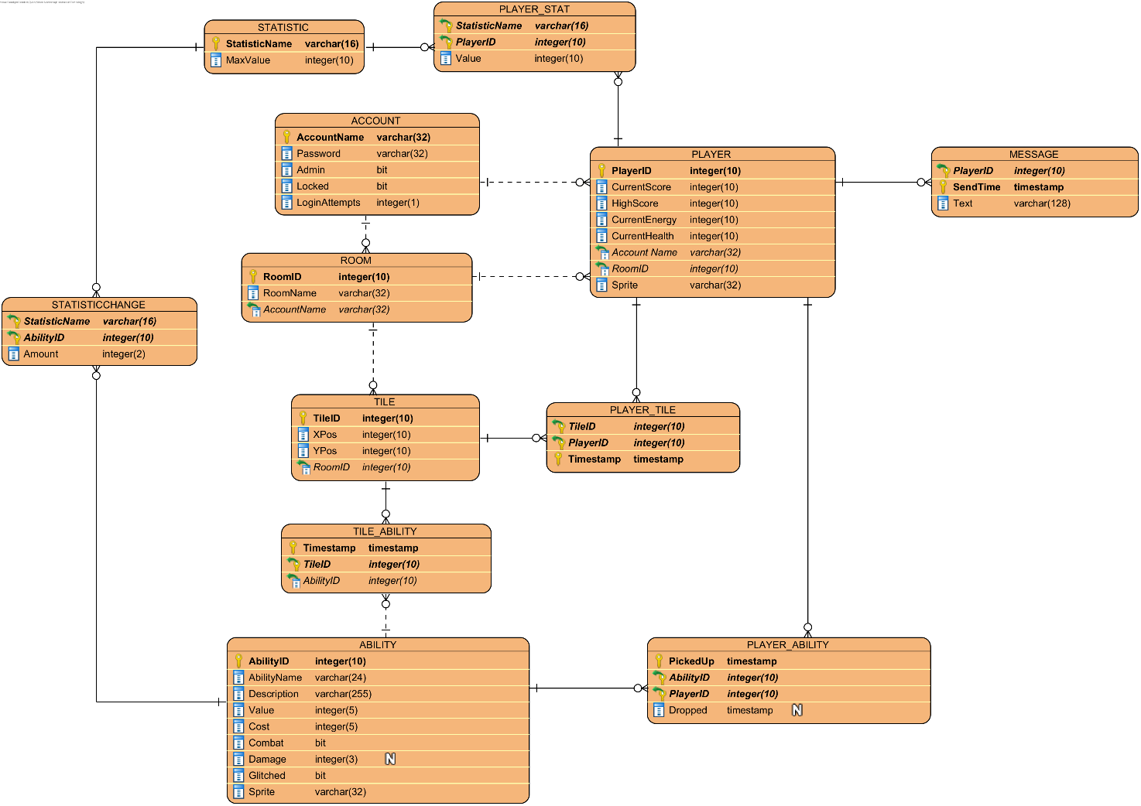

13 CRUD Table
Process > | Player Login | Incorrect Password | Player Lockout | Player Registration | Laying Out Tiles | Placing Item On Tile | Player Movement | Picking Up Item | Dropping Item | Winning Combat | Losing Combat | Glitch Item Movement | Kill A Room | Change Player Data | Delete An Account | Change Account Data | Player Join Room | Player Send Message | Create Room
Table \/
Account
AccountName (PK) | _R__ | _R__ | _R__ | CR__ | ____ | ____ | ____ | ____ | ____ | ____ | ____ | ____ | ____ | ____ | ___D | ____ | _R__ | ____ | ____
Password | _R__ | ____ | ____ | C___ | ____ | ____ | ____ | ____ | ____ | ____ | ____ | ____ | ____ | ____ | ___D | _RU_ | ____ | ____ | ____
Admin | _R__ | ____ | ____ | C___ | ____ | ____ | ____ | ____ | ____ | ____ | ____ | ____ | _R__ | ____ | ___D | __U_ | ____ | ____ | ____
Locked | _R__ | ____ | __U_ | C___ | ____ | ____ | ____ | ____ | ____ | ____ | ____ | ____ | ____ | ____ | ___D | __U_ | ____ | ____ | ____
LoginAttempts | __U_ | _RU_ | __U_ | C___ | ____ | ____ | ____ | ____ | ____ | ____ | ____ | ____ | ____ | ____ | ___D | ____ | ____ | ____ | ____
Player
PlayerID (PK) | ____ | ____ | ____ | ____ | ____ | ____ | _R__ | ____ | ____ | _R__ | ____ | ____ | ___D | ____ | ___D | ____ | C___ | _R__ | ____
CurrentScore | ____ | ____ | ____ | ____ | ____ | ____ | ____ | __U_ | __U_ | _RU_ | __U_ | ____ | ___D | __U_ | ___D | ____ | C___ | ____ | ____
HighScore | ____ | ____ | ____ | ____ | ____ | ____ | ____ | __U_ | ____ | __U_ | ____ | ____ | ___D | __U_ | ___D | ____ | C___ | ____ | ____
CurrentEnergy | ____ | ____ | ____ | ____ | ____ | ____ | ____ | ____ | ____ | ____ | ____ | ____ | ___D | __U_ | ___D | ____ | C___ | ____ | ____
CurrentHealth | ____ | ____ | ____ | ____ | ____ | ____ | ____ | ____ | ____ | ____ | ____ | ____ | ___D | __U_ | ___D | ____ | C___ | ____ | ____
AccountName (FK) | ____ | ____ | ____ | ____ | ____ | ____ | ____ | ____ | ____ | ____ | ____ | ____ | ___D | ____ | ___D | ____ | C___ | ____ | ____
RoomID (FK) | ____ | ____ | ____ | ____ | ____ | ____ | ____ | ____ | ____ | ____ | ____ | ____ | ___D | ____ | ___D | ____ | C___ | ____ | ____
Sprite | ____ | ____ | ____ | ____ | ____ | ____ | ____ | ____ | ____ | ____ | ____ | ____ | ___D | ____ | ___D | ____ | C___ | ____ | ____
Message
PlayerID (PK) (FK) | ____ | ____ | ____ | ____ | ____ | ____ | ____ | ____ | ____ | ____ | ____ | ____ | ___D | ____ | ___D | ____ | _R__ | C___ | ____
SendTime (PK) | ____ | ____ | ____ | ____ | ____ | ____ | ____ | ____ | ____ | ____ | ____ | ____ | ___D | ____ | ___D | ____ | _R__ | C___ | ____
Text | ____ | ____ | ____ | ____ | ____ | ____ | ____ | ____ | ____ | ____ | ____ | ____ | ___D | ____ | ___D | ____ | _R__ | C___ | ____
Room
RoomID (PK) | ____ | ____ | ____ | ____ | ____ | ____ | ____ | ____ | ____ | ____ | ____ | ____ | ___D | ____ | ___D | ____ | _R__ | ____ | C___
RoomName | ____ | ____ | ____ | ____ | ____ | ____ | ____ | ____ | ____ | ____ | ____ | ____ | ___D | ____ | ___D | ____ | _R__ | ____ | C___
AccountName (FK) | ____ | ____ | ____ | ____ | ____ | ____ | ____ | ____ | ____ | ____ | ____ | ____ | ___D | ____ | ___D | ____ | _R__ | ____ | C___
Player_Tile
TileID (PK) (FK) | ____ | ____ | ____ | ____ | ____ | ____ | C___ | ____ | ____ | ____ | C___ | _R__ | ___D | ____ | ___D | ____ | _R__ | ____ | ____
PlayerID (PK) (FK) | ____ | ____ | ____ | ____ | ____ | ____ | C___ | ____ | ____ | ____ | C___ | _R__ | ___D | ____ | ___D | ____ | _R__ | ____ | ____
Timestamp (PK) | ____ | ____ | ____ | ____ | ____ | ____ | C___ | ____ | ____ | ____ | C___ | _R__ | ___D | ____ | ___D | ____ | _R__ | ____ | ____
Tile
TileID (PK) | ____ | ____ | ____ | ____ | _R__ | _R__ | _R__ | ____ | _R__ | ____ | _R__ | _R__ | ___D | ____ | ___D | ____ | _R__ | ____ | C___
Xpos | ____ | ____ | ____ | ____ | _R__ | ____ | ____ | ____ | ____ | ____ | ____ | ____ | ___D | ____ | ___D | ____ | _R__ | ____ | C___
Ypos | ____ | ____ | ____ | ____ | _R__ | ____ | ____ | ____ | ____ | ____ | ____ | ____ | ___D | ____ | ___D | ____ | _R__ | ____ | C___
RoomId (FK) | ____ | ____ | ____ | ____ | _R__ | ____ | ____ | ____ | ____ | ____ | ____ | ____ | ___D | ____ | ___D | ____ | _R__ | ____ | C__
TILE_ABILITY
Timestamp (PK) | ____ | ____ | ____ | ____ | ____ | C___ | _R__ | _R__ | C___ | ____ | ____ | CR__ | ___D | ____ | ___D | ____ | _R__ | ____ | ____
TileID (PK) (FK) | ____ | ____ | ____ | ____ | ____ | C___ | _R__ | _R__ | C___ | ____ | ____ | CR__ | ___D | ____ | ___D | ____ | _R__ | ____ | ____
AbilityID (PK) (FK) | ____ | ____ | ____ | ____ | ____ | C___ | _R__ | _R__ | C___ | ____ | ____ | CR__ | ___D | ____ | ___D | ____ | _R__ | ____ | ____
Ability
AbilityID (PK) | ____ | ____ | ____ | ____ | ____ | CR__ | ____ | _R__ | _R__ | ____ | ____ | ____ | ____ | ____ | ____ | ____ | _R__ | ____ | ____
AbilityName | ____ | ____ | ____ | ____ | ____ | CR__ | ____ | _R__ | _R__ | ____ | ____ | ____ | ____ | ____ | ____ | ____ | _R__ | ____ | ____
Description | ____ | ____ | ____ | ____ | ____ | CR__ | ____ | _R__ | _R__ | ____ | ____ | ____ | ____ | ____ | ____ | ____ | _R__ | ____ | ____
Value | ____ | ____ | ____ | ____ | ____ | CR__ | ____ | _R__ | _R__ | ____ | ____ | ____ | ____ | ____ | ____ | ____ | _R__ | ____ | ____
Cost | ____ | ____ | ____ | ____ | ____ | CR__ | ____ | _R__ | _R__ | ____ | ____ | ____ | ____ | ____ | ____ | ____ | _R__ | ____ | ____
Combat | ____ | ____ | ____ | ____ | ____ | CR__ | ____ | _R__ | _R__ | ____ | ____ | ____ | ____ | ____ | ____ | ____ | _R__ | ____ | ____
Damage | ____ | ____ | ____ | ____ | ____ | CR__ | ____ | _R__ | _R__ | ____ | ____ | ____ | ____ | ____ | ____ | ____ | _R__ | ____ | ____
Glitched | ____ | ____ | ____ | ____ | ____ | CR__ | ____ | _R__ | _R__ | ____ | ____ | ____ | ____ | ____ | ____ | ____ | _R__ | ____ | ____
Sprite | ____ | ____ | ____ | ____ | ____ | CR__ | ____ | _R__ | _R__ | ____ | ____ | ____ | ____ | ____ | ____ | ____ | _R__ | ____ | ____
PLAYER_ABILITY
PickedUp (PK) | ____ | ____ | ____ | ____ | ____ | ____ | ____ | C___ | _R__ | ____ | _R__ | ____ | ___D | ____ | ___D | ____ | _R__ | ____ | ____
AbilityID (PK) (FK) | ____ | ____ | ____ | ____ | ____ | ____ | ____ | C___ | _R__ | _R__ | _R__ | ____ | ___D | ____ | ___D | ____ | _R__ | ____ | ____
PlayerID (PK) (FK) | ____ | ____ | ____ | ____ | ____ | ____ | ____ | C___ | _R__ | _R__ | _R__ | ____ | ___D | ____ | ___D | ____ | _R__ | ____ | ____
Dropped | ____ | ____ | ____ | ____ | ____ | ____ | ____ | C___ | __U_ | _R__ | __U_ | ____ | ___D | ____ | ___D | ____ | _R__ | ____ | ____
StatChange
AbilityID (PK) (FK) | ____ | ____ | ____ | ____ | ____ | C___ | ____ | _R__ | ____ | ____ | ____ | ____ | ____ | ____ | ____ | ____ | _R__ | ____ | ____
StatName (PK) (FK) | ____ | ____ | ____ | ____ | ____ | C___ | ____ | _R__ | ____ | ____ | ____ | ____ | ____ | ____ | ____ | ____ | _R__ | ____ | ____
Amount | ____ | ____ | ____ | ____ | ____ | C___ | ____ | _R__ | ____ | ____ | ____ | ____ | ____ | ____ | ____ | ____ | _R__ | ____ | ____
Stat
StatName (PK) | ____ | ____ | ____ | ____ | ____ | C___ | ____ | _R__ | ____ | ____ | ____ | ____ | ____ | ____ | ____ | ____ | _R__ | ____ | ____
MaxValue | ____ | ____ | ____ | ____ | ____ | C___ | ____ | _R__ | ____ | ____ | ____ | ____ | ____ | ____ | ____ | ____ | _R__ | ____ | ____
Player_Stat
StatName (PK) (FK) | ____ | ____ | ____ | ____ | ____ | ____ | _R__ | _R__ | _R__ | ____ | ____ | ____ | ___D | ____ | ___D | ____ | CR__ | ____ | ____
PlayerID (PK) (FK) | ____ | ____ | ____ | ____ | ____ | ____ | _R__ | _R__ | _R__ | ____ | ____ | ____ | ___D | ____ | ___D | ____ | CR__ | ____ | ____
Value | ____ | ____ | ____ | ____ | ____ | ____ | _R__ | __U_ | __U_ | ____ | ____ | ____ | ___D | ____ | ___D | ____ | CR__ | ____ | ____

14 Prototype
14.1 Login Screen
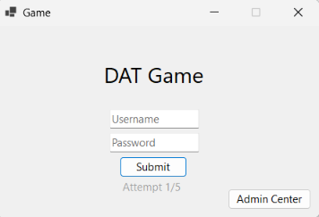
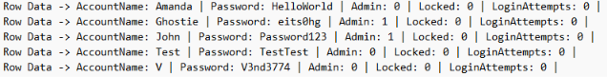

14.2 Gameplay Screen
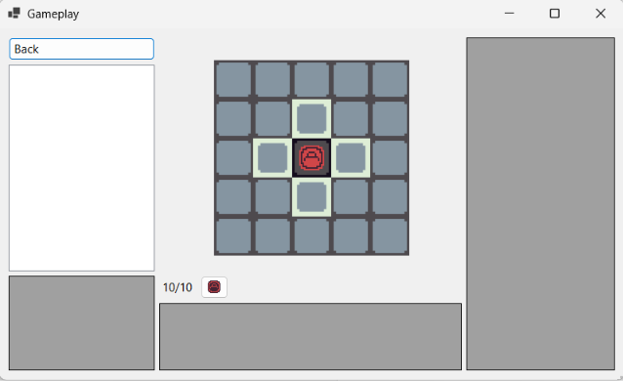
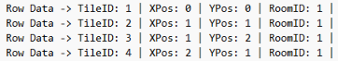

14.3 Administration Screen
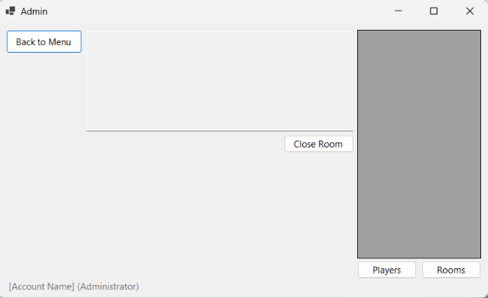

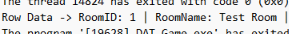

15 DDL
The DDL procedure uses one create table statement for each table in the database; it sets the primary key(s) and any foreign key(s) after defining each column. The procedure then inserts the test data in the same order which the tables were created in.

